Create an account:
- Enter your full name, email address, password of your choice
- If you do NOT have an email address, see your teacher for a general one you may use throughout this assignment
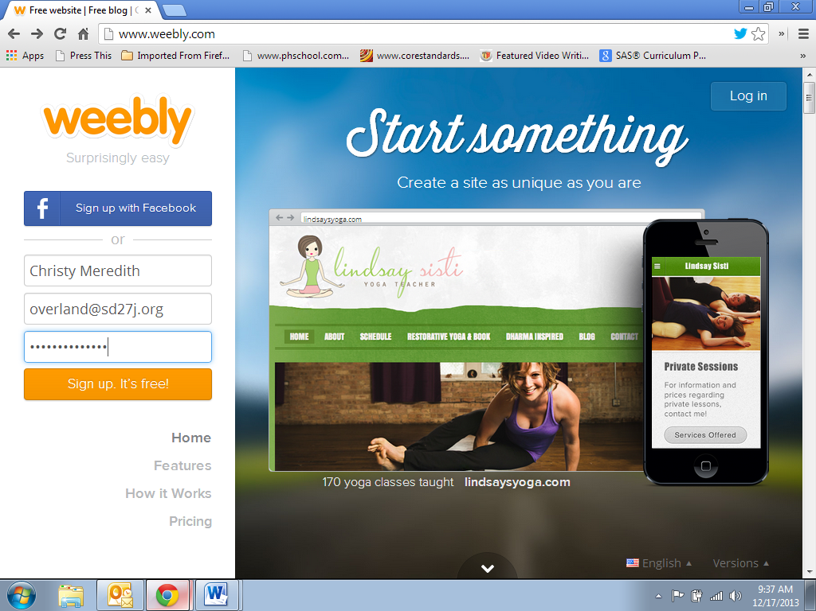
Create a “SITE”
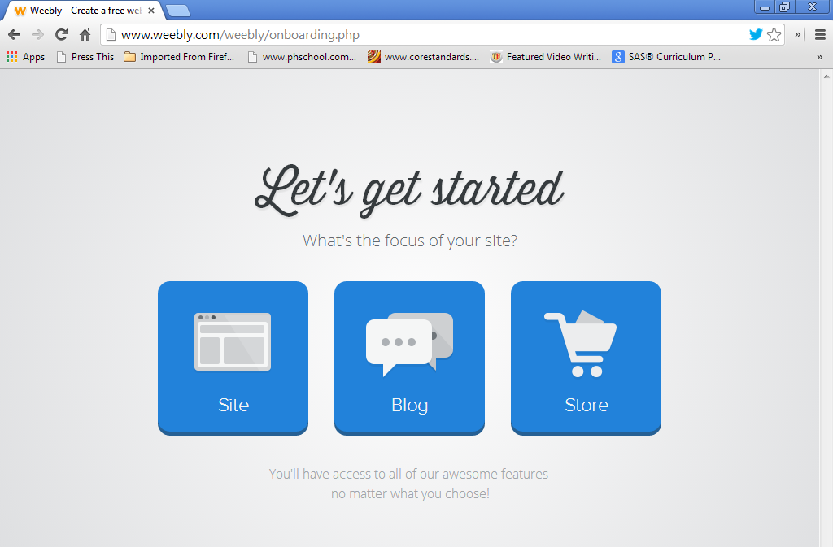

Selecting your site theme
- Select a theme with a Large Image since you’ll need to upload your own drawing of your superhero or villain
- You can change this at another date if you feel it’s not perfect later
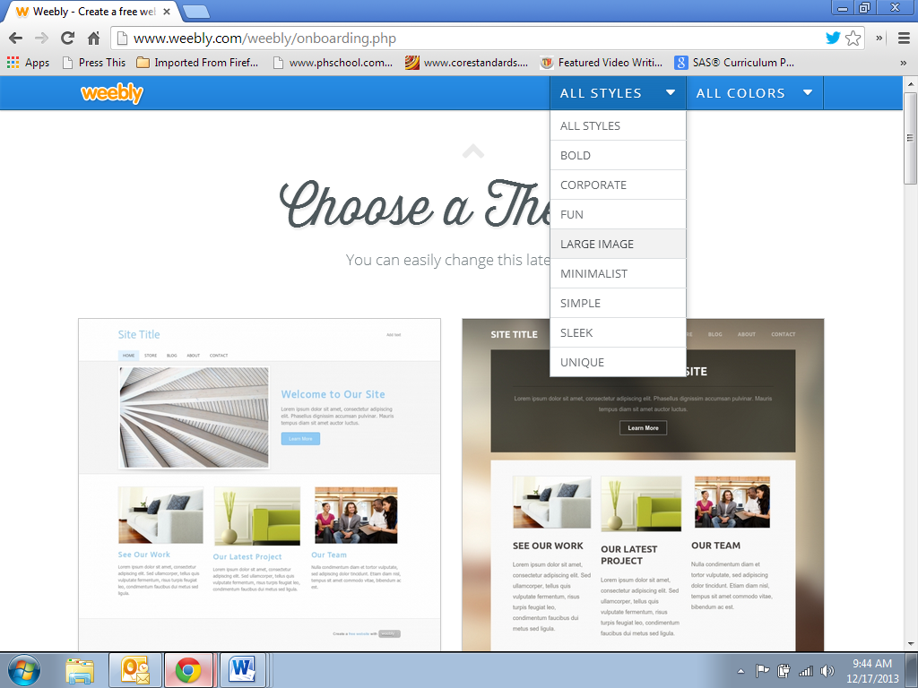

Web Domain
Register with a Weebly Domain name: OTMS_____(character name class period B)______.weebly.com
EX: www.OTMSCaptainAmerica4B.weebly.com
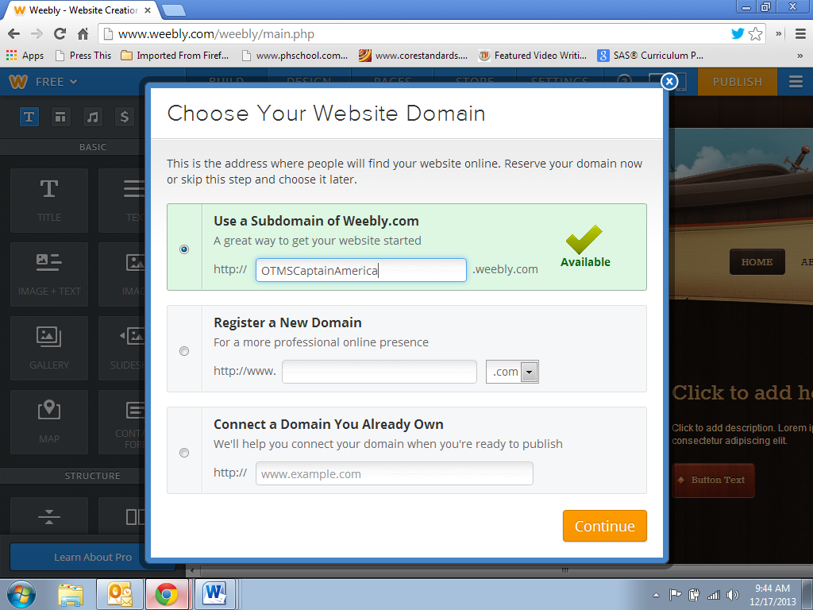
Setting up your pages
- Click “Pages” on the top toolbar
- Select “Add Page” and add as many pages as needed for the assignment (see example)
- Edit each page name – you can drag and drop them in the order needed (see example)
- You may choose the page layout you prefer – decide if that page will need an image or not
- **The “Loading Page” should be the “Origins” page (see example)
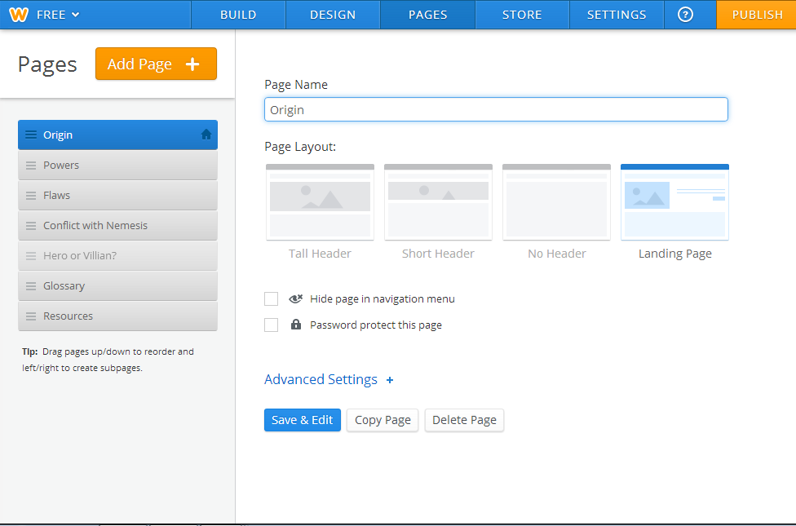
Tutorials
- There are tutorials on weebly for everything you may be interested in doing or need help with. Utilize these videos before approaching your teacher for help. Just like “the real world”, oftentimes we don’t have someone to run to for help. Problem-solving is key to survival.
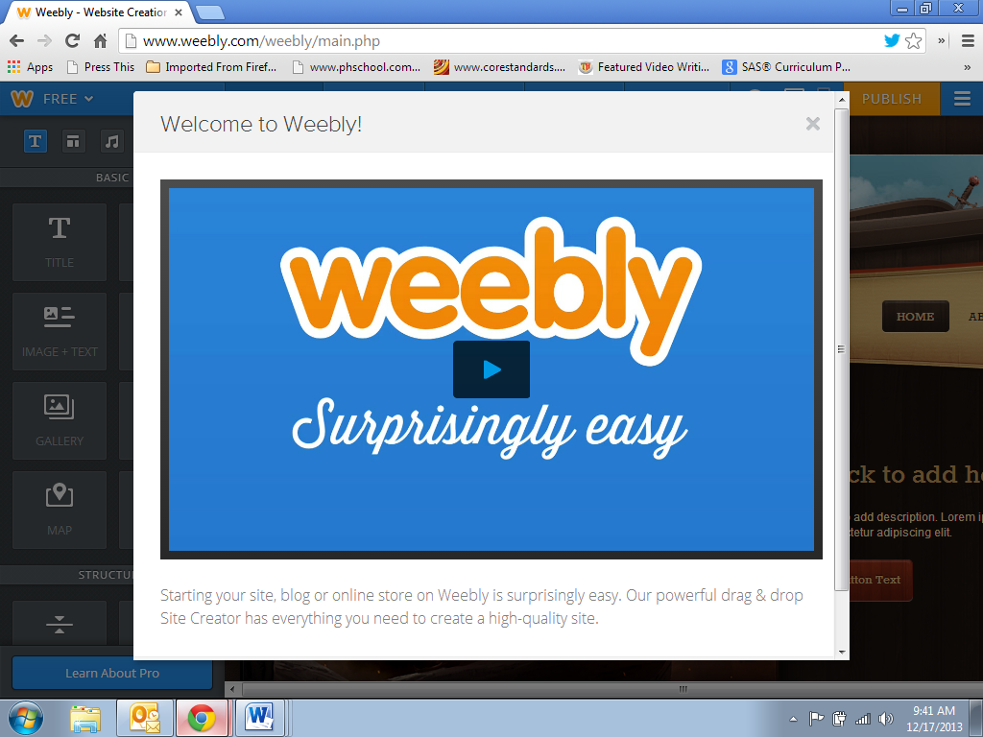

Explore, Learn, Teach Others
- Work on each page required – be sure you provide sufficient information as detailed on the rubric. You can choose the layout, insert images (that are free of copyright, which Weebly helps you with), hyperlinks to resources, youtube videos, slideshows, etc.
  - Origins
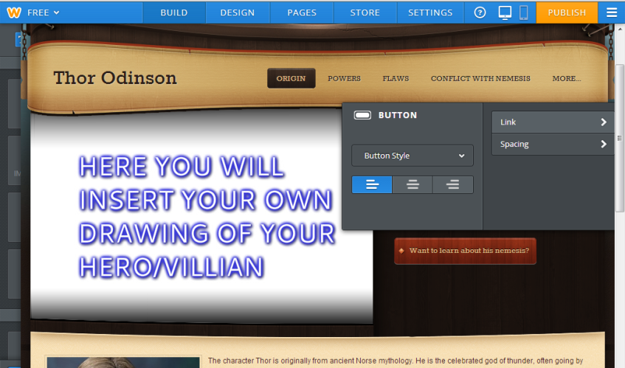
  - Powers
  - Flaws
  - Conflict with Nemesis
  - Hero or Villain?
  - Glossary
  - Resources
- Link to your nemesis’ page on the home “Origins” page (see example)
  - This will have to be done last once your partner has completed his/her page and possibly after you publish, you’ll have to go back in and insert this link
Once Done: Publish – be sure to categorize your site as “Education” and “Class Project” – you can still go back and edit

