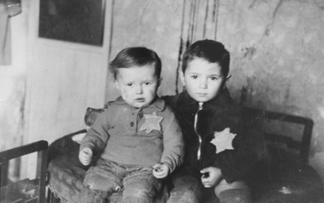
#1 Nonfiction Ideas:
- Holocaust
- War
- Children
- Brothers
- Siblings
- Judaism
- Religion
- Adolf Hitler
- Nazi

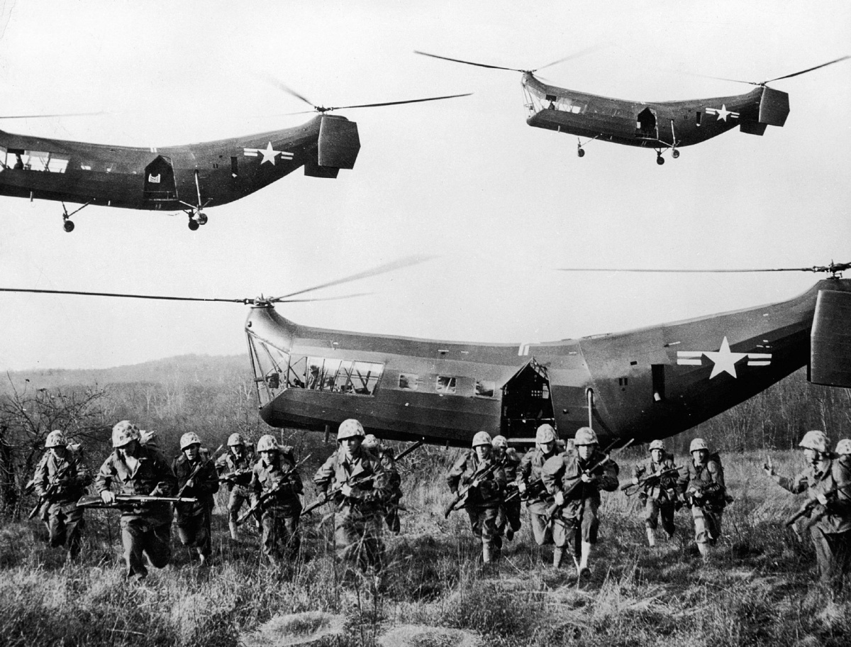

#2 Nonfiction Ideas:
- War
- Helicopters
- Fighter planes
- Soldiers
- Brotherhood
- President
- (any specific war)
- (any infantry names)
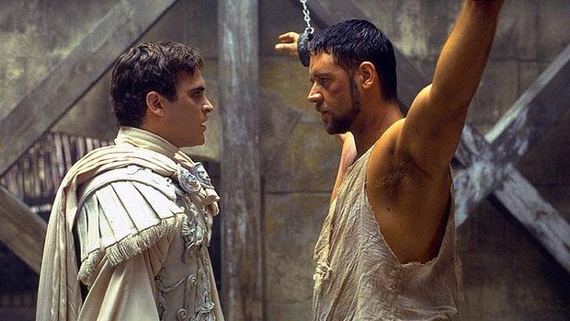
#3 Nonfiction Ideas:
- Gladiator
- Rome
- Emperor
- Slavery
- Coliseum
- Marcus Aurelius
- Commodus
- Warrior
#4 Nonfiction Ideas:
- Cooking
- Family
- Italian
- Mexican
- Chinese
- Salad

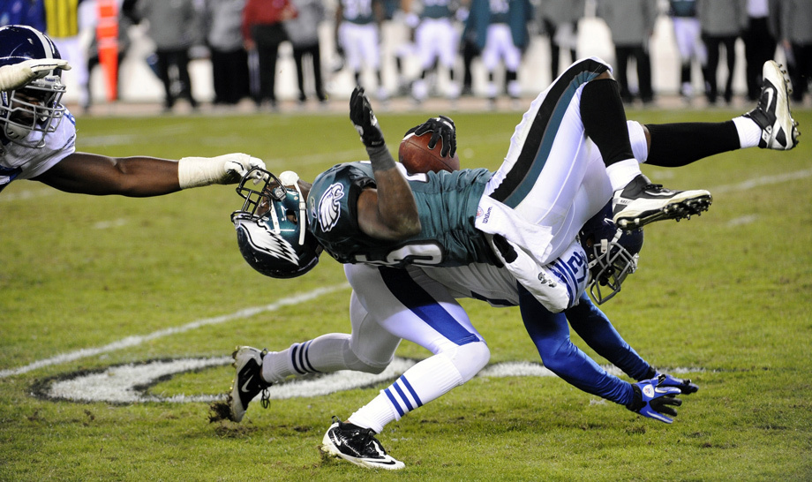
#5 Nonfiction Ideas:
- Football
- Offense
- Defense
- Rules
- Sports
- (any team)
- (any coach)
- (any player)
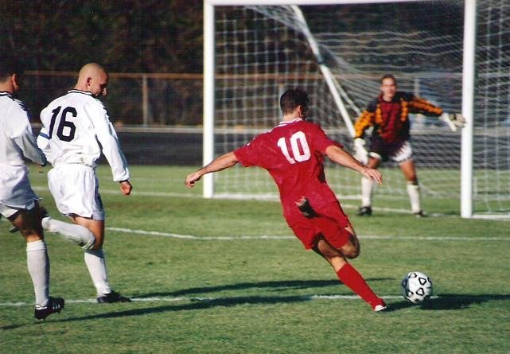
#6 Nonfiction Ideas:
- Soccer
- Offense
- Defense
- Rules
- Sports
- (any team)
- (any coach)
- (any player)
#7 Nonfiction Ideas:
- Basketball
- Offense
- Defense
- Rules
- Sports
- (any team)
- (any coach)
- (any player)
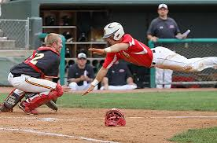

#8 Nonfiction Ideas:
- Baseball
- Softball
- Sports
- International Sports
- (any position)
- (any team)
- (any player)
- (any coach)
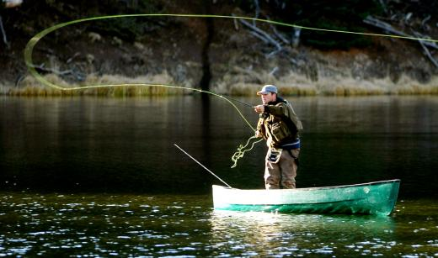
#9 Nonfiction Ideas:
- Fly Fishing
- Fishing
- Recreation Sports
- Nature
- Mountains
- Being alone
- (any body of water)
- (any location fitting this image)
#10 Nonfiction Ideas:
- Dogs
- Service Dogs
- Hospitals
- Children
- Health
- (any disease/sickness)
- (specific dog breed)

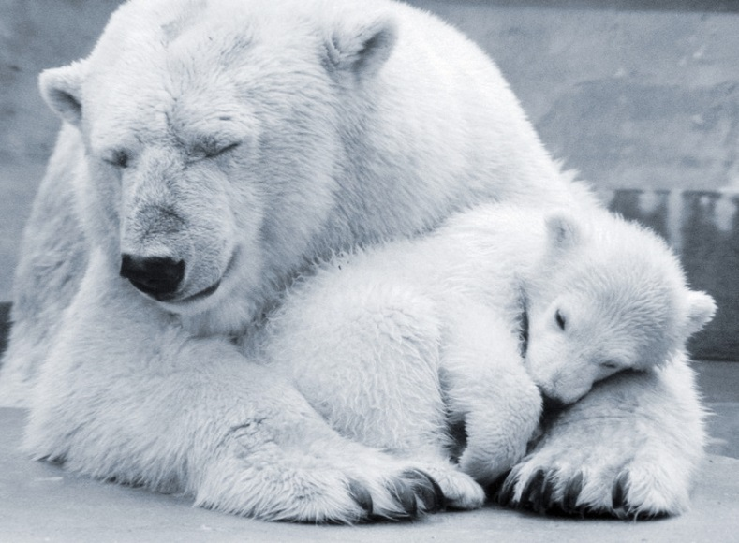

#11 Nonfiction Ideas:
- Polar Bear
- Antarctic
- Endangered Animals
- Zoos
- Cubs

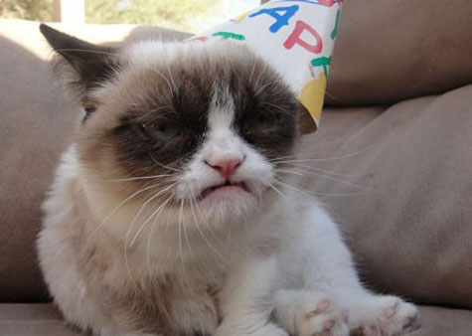
#12 Nonfiction Ideas:
- Cats
- Birthdays
- Celebrations
- Holidays
- Emotions

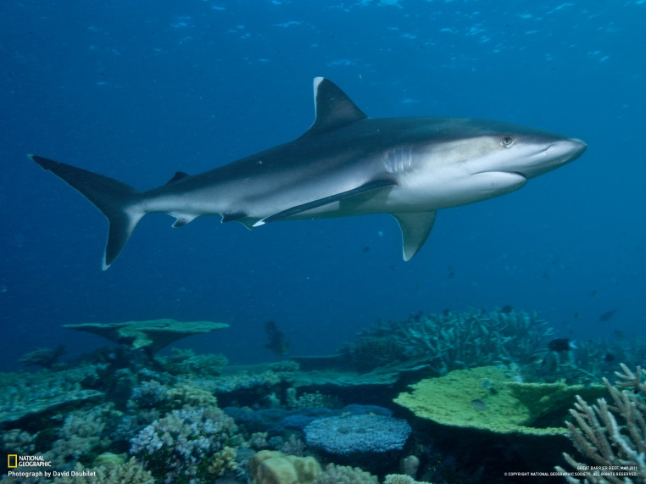

#13 Nonfiction Ideas:
- Sharks
- Shark Behaviors
- Shark Attacks
- Oceans
- Endangered Animals
- Ocean Floor

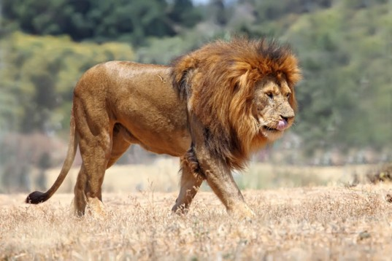

#14 Nonfiction Ideas:
- Lion
- Africa
- Endangered Animals
- Animal Sanctuary
- Zoo

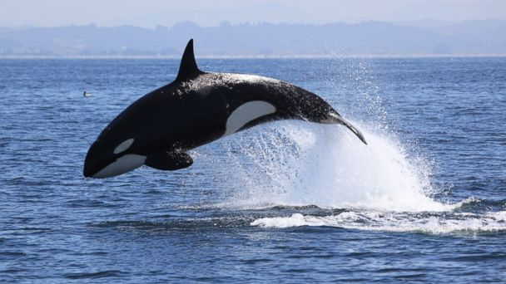
#15 Nonfiction Ideas:
- Killer Whale
- Whale
- Blackfish
- Endangered Animals
- Zoos
- Sea World
- Health
- Caring for…
- Migration
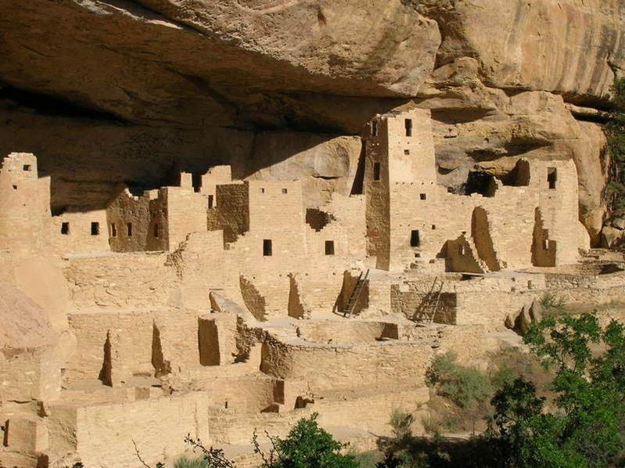

#16 Nonfiction Ideas:
- Cliff Dwellings
- Cliff Dwellers
- Mesa Verde
- Colorado
- Civilization
- Pottery

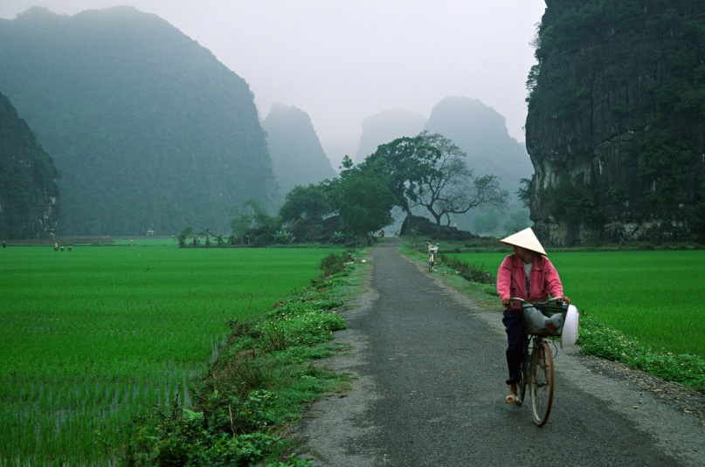
#17 Nonfiction Ideas:
- Vietnam
- Vietnam War
- Vietnam Customs
- Vietnamese American

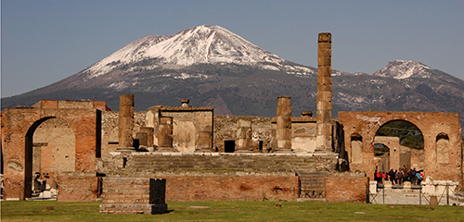
#18 Nonfiction Ideas:
- Pompeii
- Italy
- Extinct Cities
- Rome
- Volcano
- Mount Vesuvius
- Gladiators

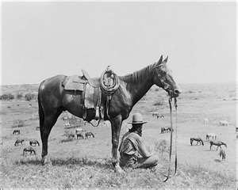

#19 Nonfiction Ideas:
- Wild West
- Cowboys
- Horses
- Cattle Drive
- Outlaws
- Peace Officers
- Pioneer Life
- U.S. West History
- (any outlaw)
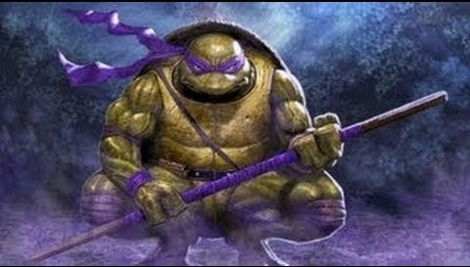
#20 Nonfiction Ideas:
- Ninja
- Samurai
- Turtle
- Japan
- Military
- Japan History

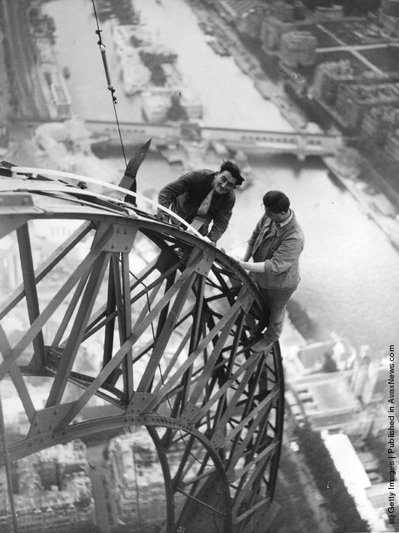

#21 Nonfiction Ideas:
- Electrical
- France
- Eiffel Tower
- Construction
- France History
- Paris

#22 Nonfiction Ideas:
- Swimming
- Summer Olympics
- Competition
- Medals
- (any swimmer)

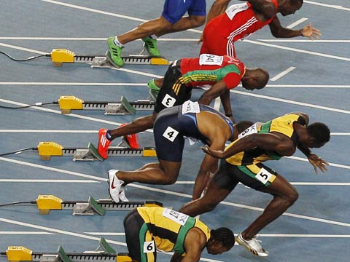

#23 Nonfiction Ideas:
- Track
- Track and Field
- Running
- Olympics
- Improving Speed
- (any country that competes)
- (any runner)
- (any track star)

#24 Nonfiction Ideas:
- Farming
- Farm Life
- Agriculture
- Tractors
- Food Supply
- Habitats in Danger

#25 Nonfiction Ideas:
- Aerospace
- Airplanes
- Travel
- Wright Brothers
- NASA
- Air Travel
- Black Eagles
- Aerospace Engineer
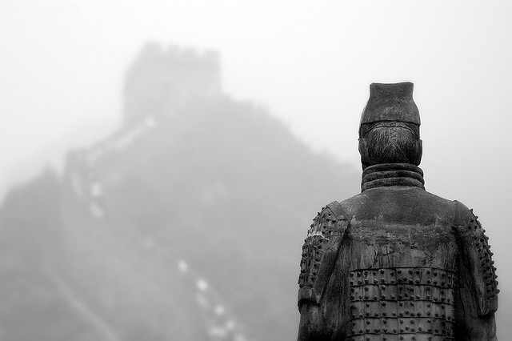
#26 Nonfiction Ideas:
- China
- Great Wall of China
- Emperor
- World Heritage
- Ming Dynasty
- Chinese Empire
- Construction
- War
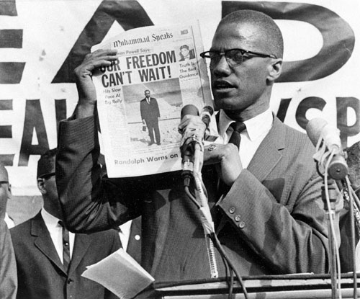
#27 Nonfiction Ideas:
- Civil Rights
- African American
- Segregation (and Desegregation)
- Freedom
- Racism
- (people of the Civil Rights movement)
- (states for or against Civil Rights)

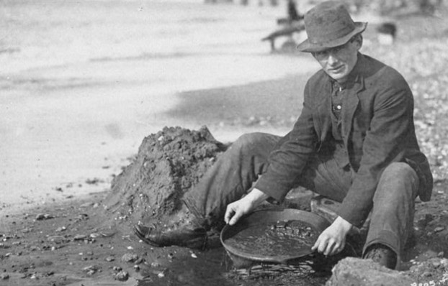
#28 Nonfiction Ideas:
- Gold Rush
- California
- Mines and Mineral Resources
- Gold Mines

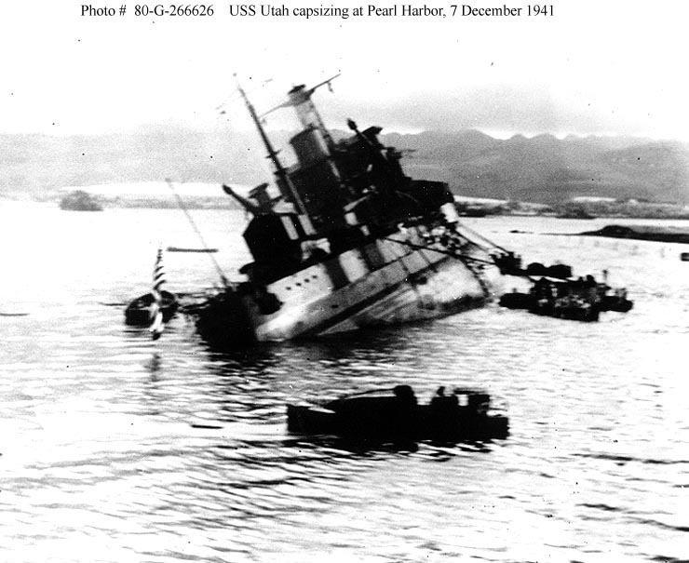

#29 Nonfiction Ideas:
- Battleships
- Pearl Harbor
- Attacks by water
- Japan
- Navy
- Military
- Franklin D. Roosevelt

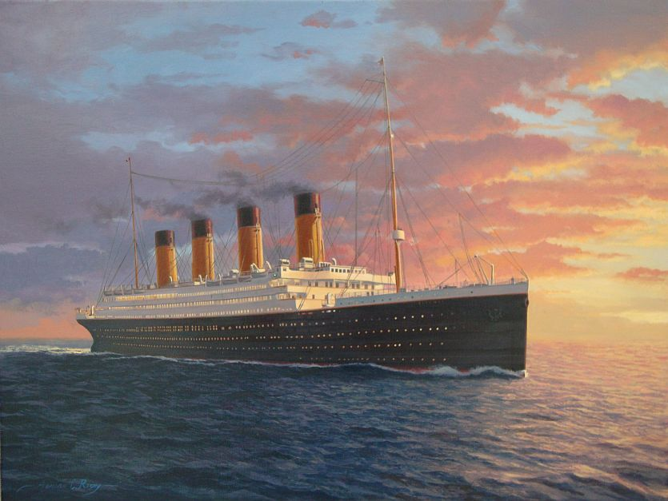

#30 Nonfiction Ideas:
- Titanic
- Travel
- Shipwrecks
- Underwater Exploration
- Disasters
- Boats

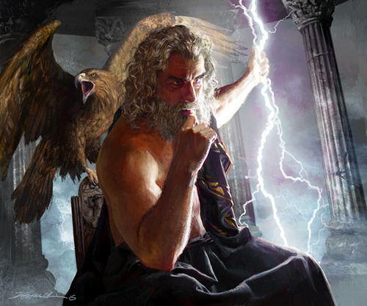

#31 Nonfiction Ideas:
- Mythology
- (any Greek or Roman god)
- (any Greek or Roman hero)
- (any Greek or Roman story)

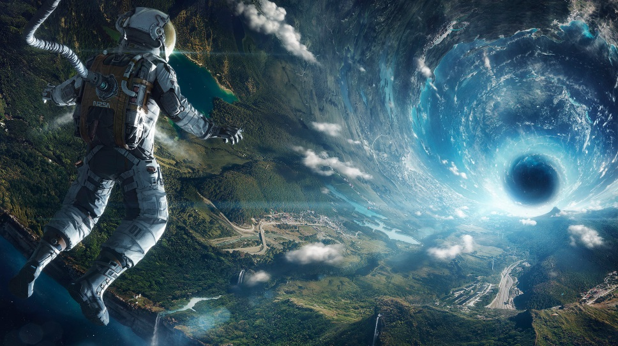
#32 Nonfiction Ideas:
- Space
- Astronauts
- Space Travel
- Landing on the Moon
- (any planet)
- (any astronaut)

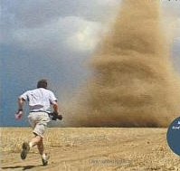

#33 Nonfiction Ideas:
- Weather
- Tornado
- Storm Chaser
- Photography
- Videography
- (any natural disaster)

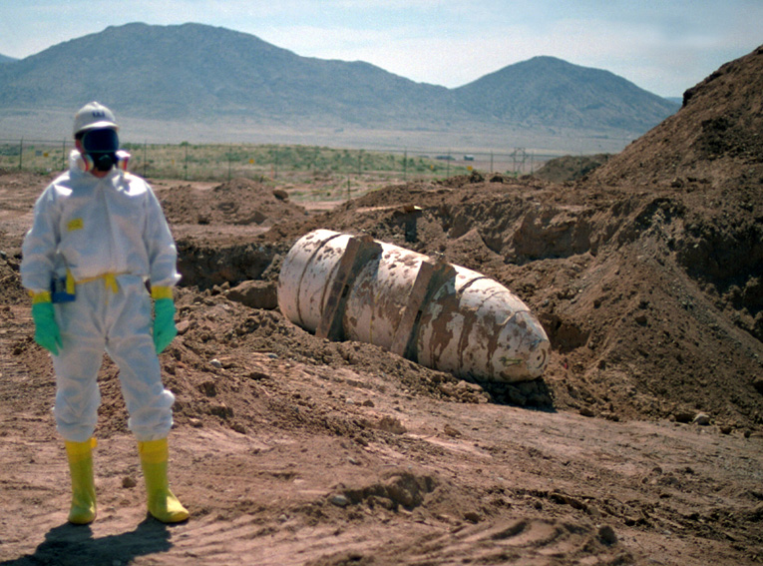
#34 Nonfiction Ideas:
- Elements (Period Table)
- Bombs
- Atomic Bomb
- Hydrogen Bomb
- Hiroshima
- World War II
- Forensics
- Detective
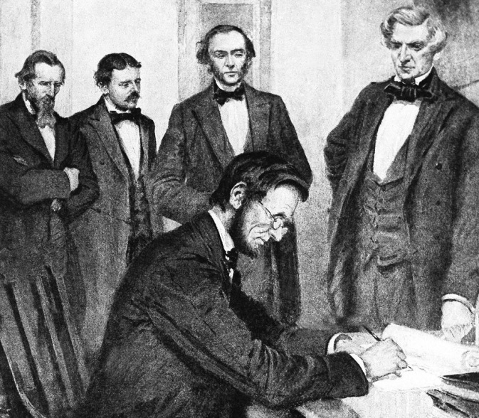

#35 Nonfiction Ideas:
- Abraham Lincoln
- Conspiracy
- Assassination
- Emancipation Proclamation
- Slavery
- North vs. South
- Declaration

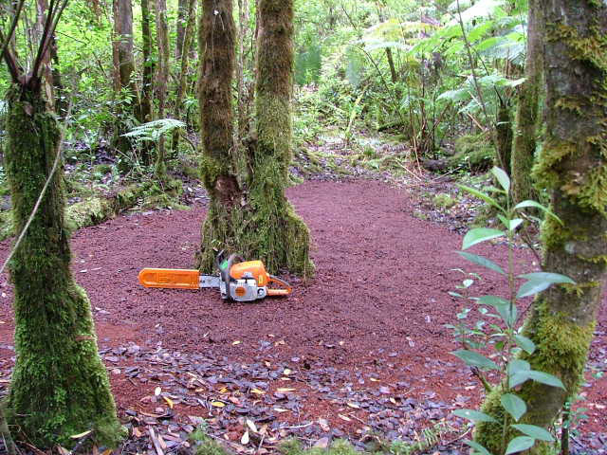

#36 Nonfiction Ideas:
- Rain Forest
- Amazon
- Alaska
- Deforestation
- Endangered Animals
- Conservation
- Ecology
- Forest
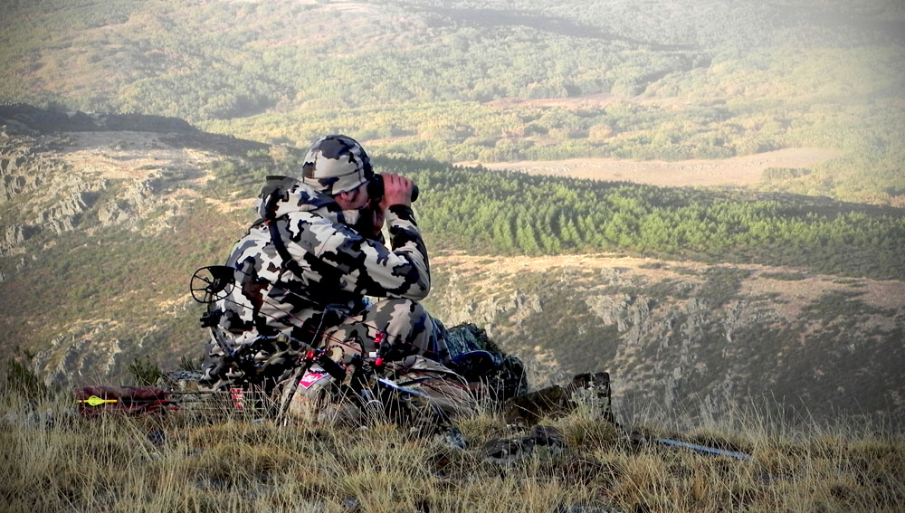
#37 Nonfiction Ideas:
- Hunting
- Archery
- Conservation
- Wildlife
- Photography
- (any animal)

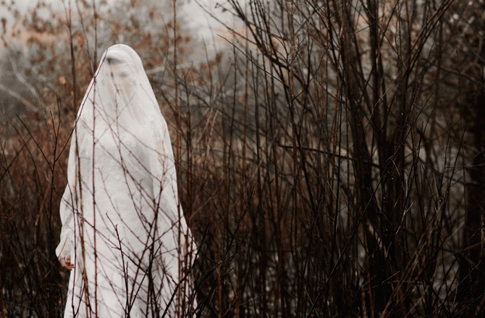
#38 Nonfiction Ideas:
- Ghosts
- Ghost Hunting
- Ghost Towns
- Ghosts of War
- Haunted Houses
- Supernatural
- Photography
- Mystery
#39 Nonfiction Ideas:
- Photography
- National Geographic
- Camera
- Digital vs Film
- (any time era for photography)
- (anything that could be on the other side of the lens)

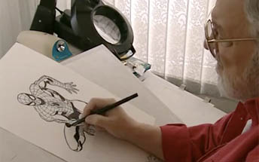
#40 Nonfiction Ideas:
- Drawing
- Cartoons
- Comics
- How to Draw
- (any comic)
- (any comic creator)
**Nonfiction texts dealing with the art of drawing, not just teaching you how to draw
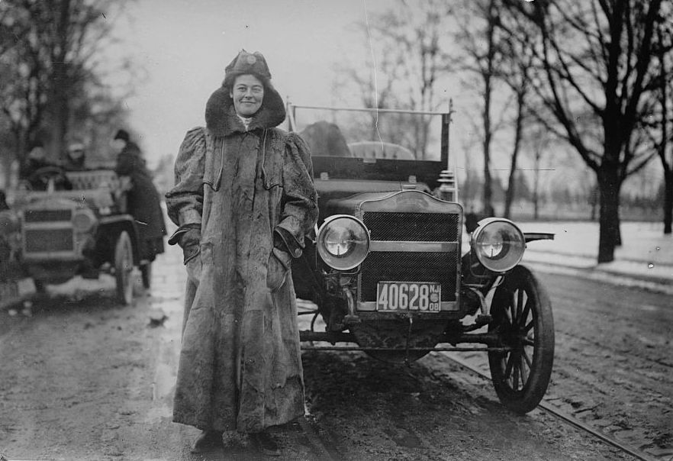
#41 Nonfiction Ideas:
- Cars
- Henry Ford
- Maintenance
- Racing
- NASCAR
- Wheels
- Driving

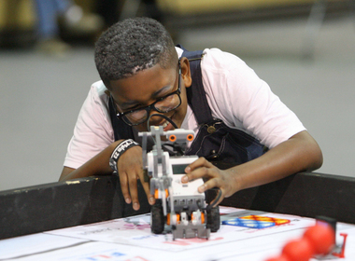
#42 Nonfiction Ideas:
- Inventors
- Inventions
- (any inventor)
- (any invention)

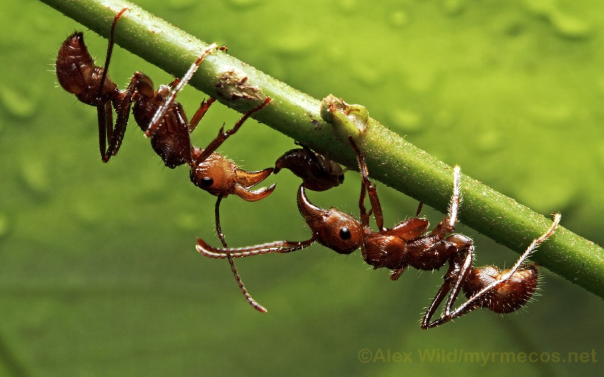
#43 Nonfiction Ideas:
- Insects
- Bugs
- Camouflage
- Animal Behavior
- (any insect)

#44 Nonfiction Ideas:
- Sickness
- Disease
- Medicine
- Microorganism
- Health
- (any disease)

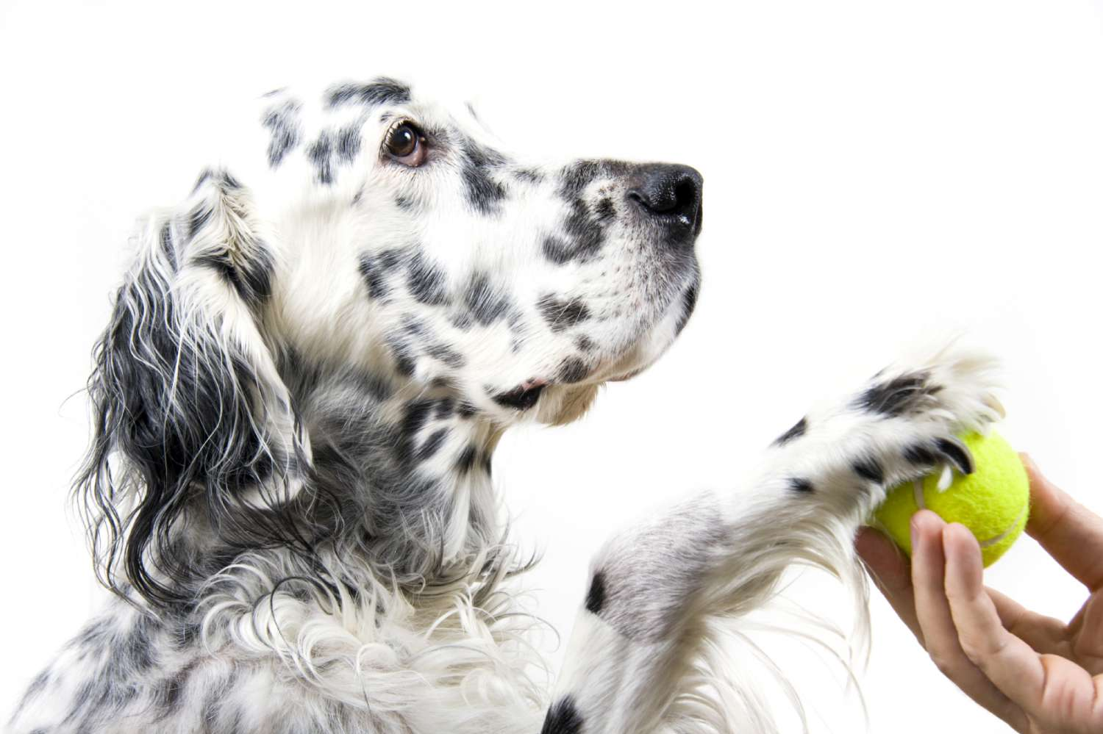
#45 Nonfiction Ideas:
- Dogs
- Training
- Competition
- Dog Shows
- (any breed)

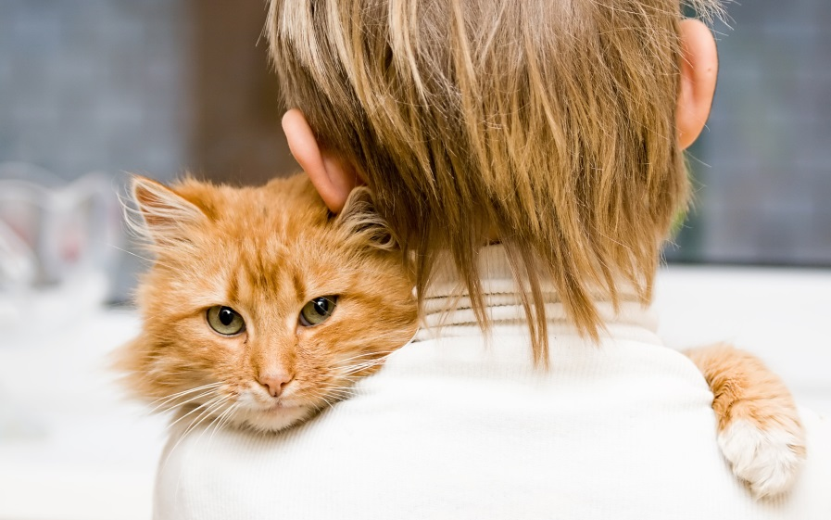
#46 Nonfiction Ideas:
- Cats
- Owner
- Training
- Comfort
- Emotional Support
- (any breed)

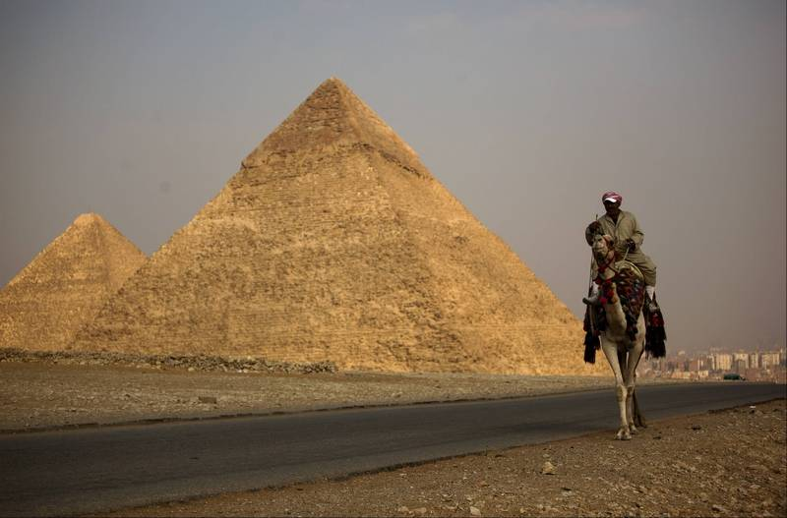
#47 Nonfiction Ideas:
- Egypt
- Pyramids
- Hatshepsut
- King Tut
- Mummies
- Tombs
- Camels

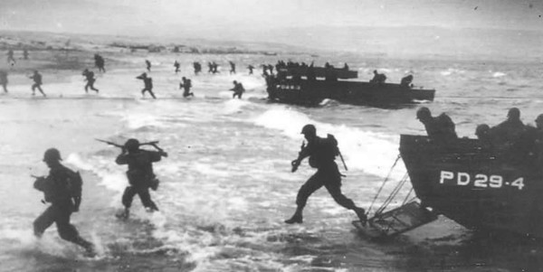
#48 Nonfiction Ideas:
- World War I
- World War II
- D-Day
- Normandy
- Allies
- Navy
- Soldiers

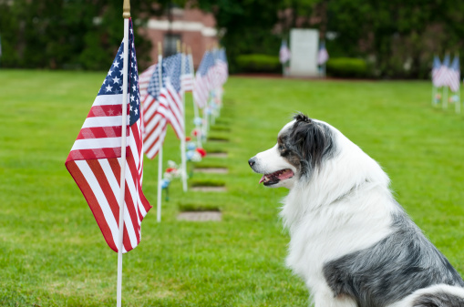
#49 Nonfiction Ideas:
- American Flag
- Battle of 1812
- Star-Spangled Banner
- Pledge of Allegiance
- Betsy Ross
- National Songs
- Soldiers
- Veterans
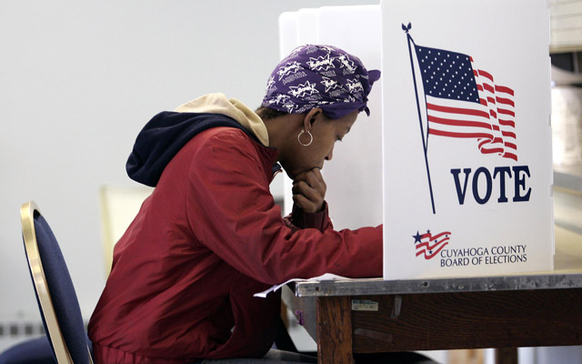
#50 Nonfiction Ideas:
- Voting
- Women’s Rights
- Wyoming (first state to allow women the right to vote)
- Congress
- Presidents
- Senate
- Election
- Democracy

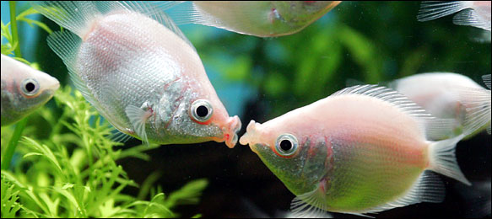
#51 Nonfiction Ideas:

- Fish
- Relationships
- Ocean
- Kissing
- House Pets
- (any breed)

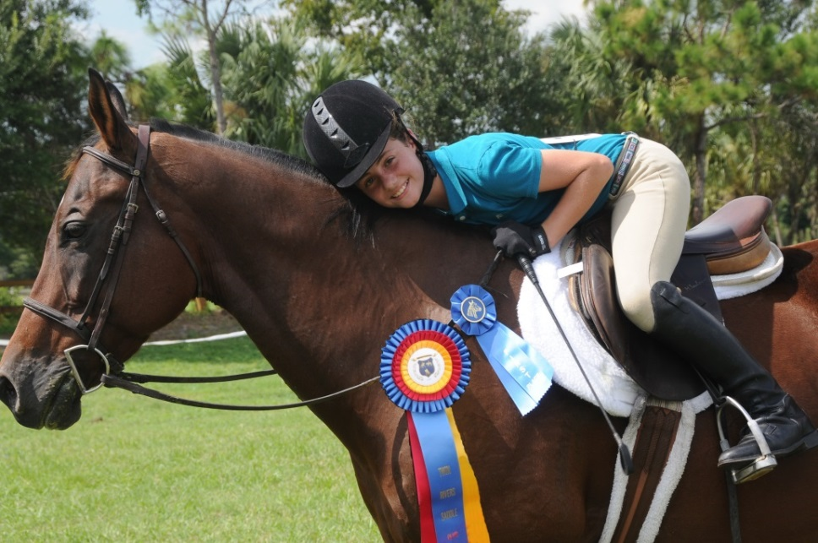
#52 Nonfiction Ideas:
- Horses
- Horse Show
- Horse Training
- 4-H
- Wild Horses
- (specific training style)
- (specific riding style)
- (any breed)
- (time era for horses)

