- Go to easybib.com
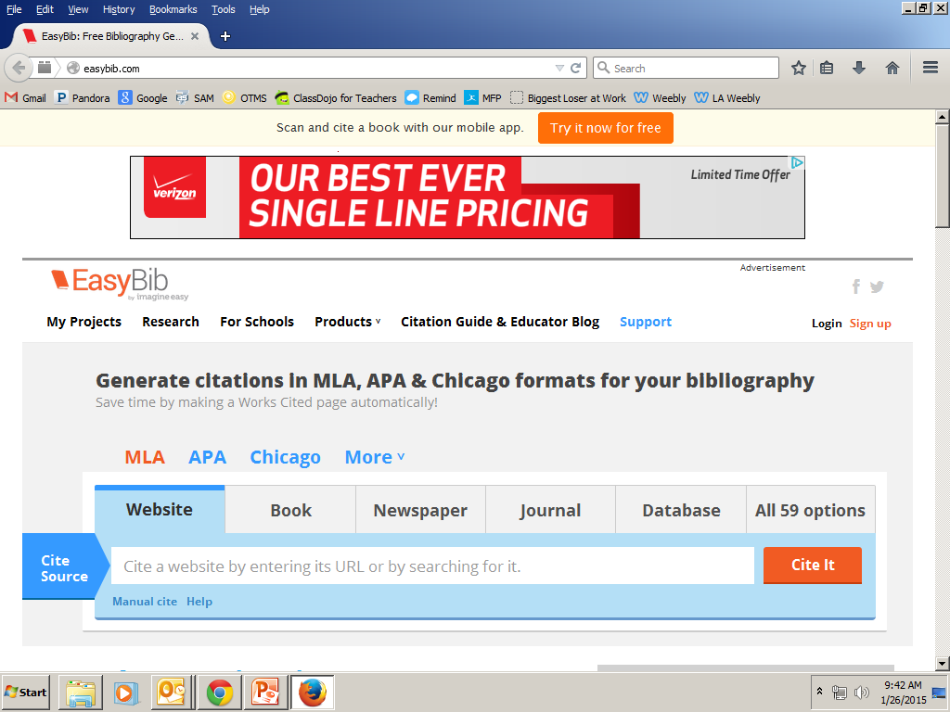
2. Click on ‘website’ and then paste your site in the ‘cite source’ location.
3.) After you have pasted in your site, click the ‘cite it’ button.
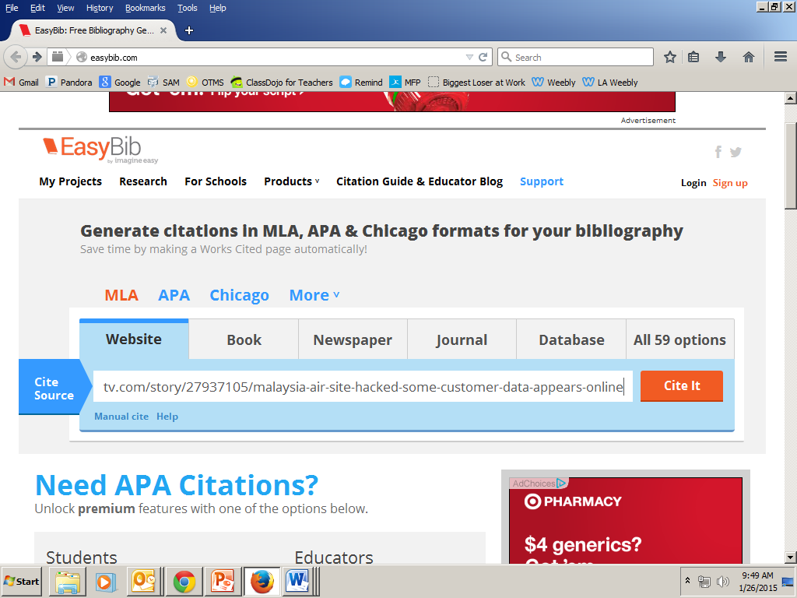
4.) The website will produce your ‘cite’. Scroll down and hit the ‘continue’ button.
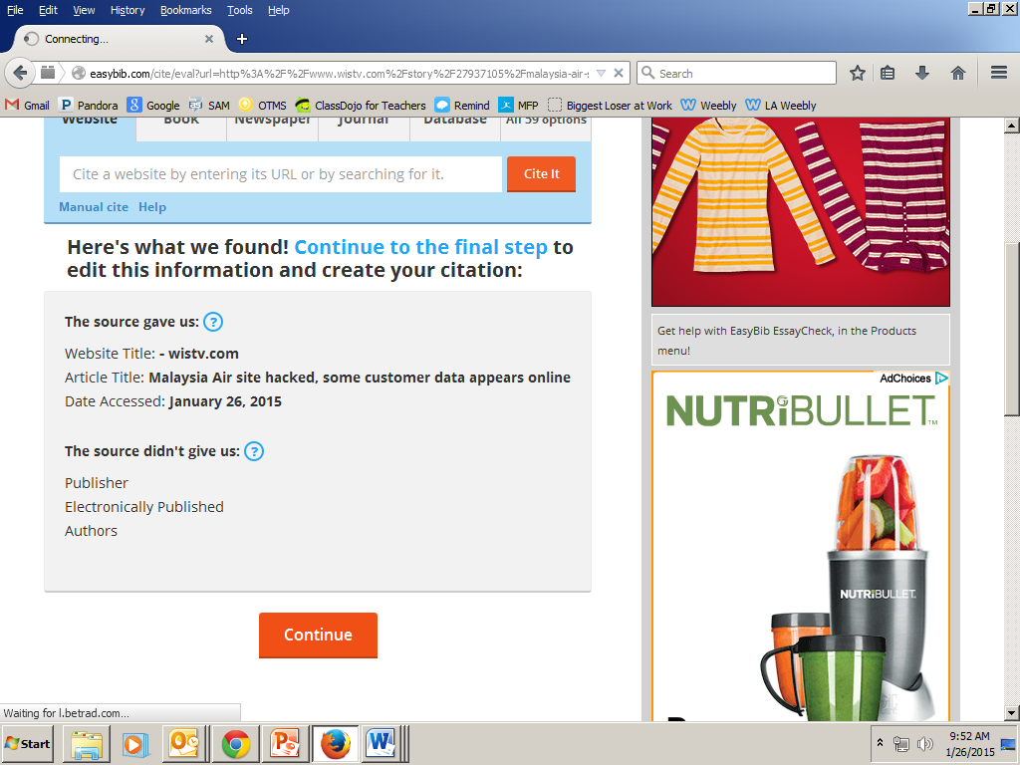
5.) The website will show you items that might be missing. Scroll down to the bottom and click ‘create citation’
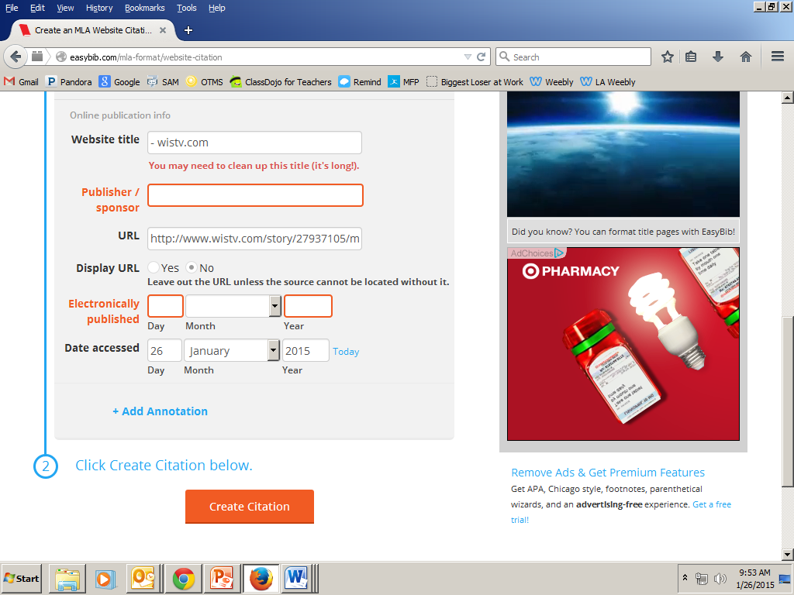
5.) Once you have created your citation, highlight it. Then right click and click ‘copy’.
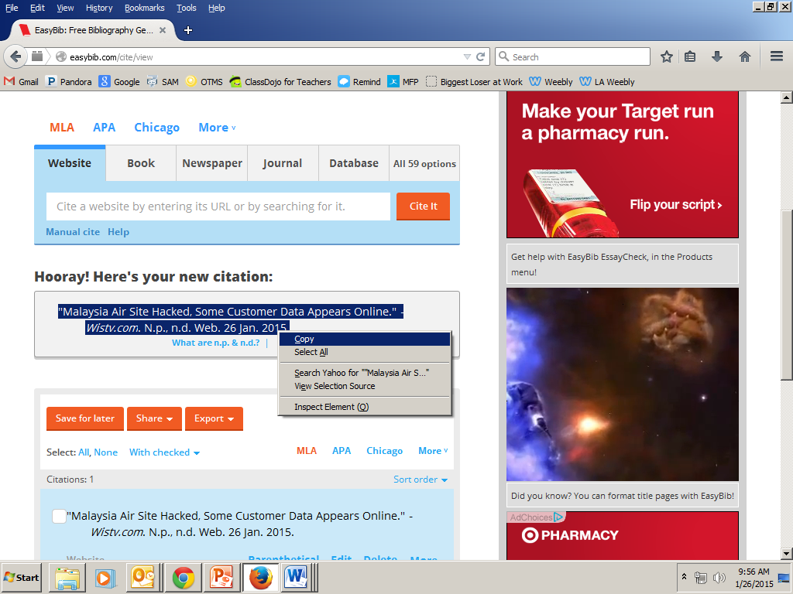
6.) Open your word document to your ‘Works Cited’ page (it should be a separate page from your paper) and paste your citation there. You are done!

