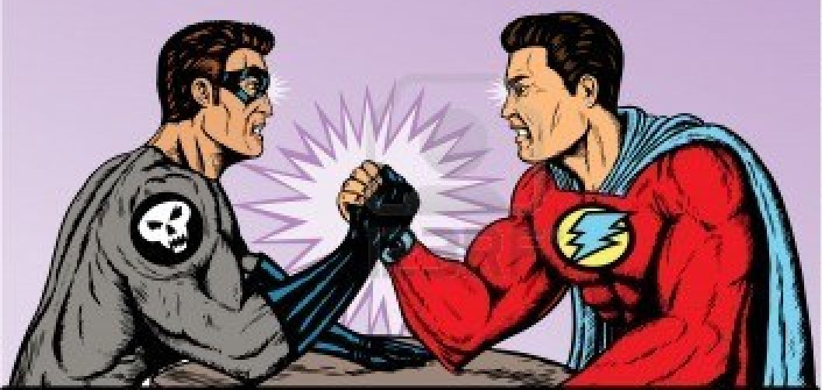

Over the course of the next three weeks, you will be researching a hero or a villain whom you’ll choose during class. Your hero or villain has an arch nemesis (or more than one), who will also be researched in your class by someone else. These heroes and villains have had an impact on society throughout history, whether they are ancient gods worshiped by the Norse or a villain whose necessity in life is a result of a hero’s presence. Your job = research all you can about your hero/villain (on sites OTHER THAN Wikipedia) and create an elementary school-friendly website reporting your findings.
REQUIREMENTS:
- Weebly website which includes the following SEVEN pages:
  - “Origin” - Origin of name & why they’re called that, how they became that hero/villain (Ex. How Bruce Wayne became Batman), and when the character first appeared in comics (or other media)
  - “Powers” – List + description of their powers
  - “Flaws” - Character or Power Flaws – List + description of each
  - “Conflict with nemesis” – historical reasoning why there’s the conflict with their nemesis (the backstory)
  - “Hero or Villain” – Persuasive essay detailing: Are they good or evil? Or in between? Why?
  - “Glossary”– lists all vocabulary (see back) and their definitions specific to this research project. You must also incorporate FIVE throughout the website. You must also include FIVE vocabulary you’ve used in your writing that will help elementary-aged kids with definitions, but this is not included in the five required. ALL Vocabulary must be bolded in the text as well.
  - “Resources” – lists in alphabetical order all resources (MINIMUM OF TWO) used during research to help gather information for your website. Must be a MLA formatted bibliography with hyperlinks/URLs. WIKIPEDIA is not allowed. You can use easybib.com to help you create your bibliography.
- Scanned image of your original drawing to put on the “Origins” page, clear title and subheadings, grammar/spelling/punctuation errors
- Scanned image of their original drawing featuring their hero/villain against his/her nemesis on the “Conflict with Nemesis” page
- Hyperlink on the “Origins” page to the nemesis’ page which another student in class has created
VOCABULARY (These terms need to be looked up and written into your journal; they must also appear on your webpage’s Glossary):
- Protagonist
- Antagonist
- Hero
- Villain
Example Websites:
www.otmsthor.weebly.com
www.otmsloki.weebly.com
- Arch nemesis
- Sidekick
- Flaw
- Character traits
- Backstory
- Origin
- Identity
- Allusion
- Symbol
- Internal conflict
- External conflict
- Foil
RUBRIC:
URL of website for evaluation: ____________________________________________________________
Origins page
0 1 2
Powers page
0 1 2
Flaws page
0 1 2
Conflict with Nemesis page
0 1 2
Hero or Villain Persuasive Essay Page
0 1 2

Glossary: Elementary Appropriate
0 1 2
Resources/MLA Bibliography
0 1 2
Original Drawing of Character
0 1 2
Original Drawing of Hero vs. Villain
0 1 2
Grammar, Spelling, Punctuation
0 1 2

OVERALL SCORE: _________________/20

What’s expected in terms on each page of your site:
ORIGINS:
- 2 paragraphs
  - 1 about when he/she first showed up in comics and who his/her creator was
  - 1 about how he/she became that character.
    - Example: I’d tell how Bruce Wayne became Batman.
- Original drawing of your character (not traced, not looking at another picture to copy it)
POWERS:
- Introductory paragraph introducing what this page is about
- List all of the powers and describe each and how it helps your character
FLAWS:
- Introductory paragraph introducing what this page is about
- List all of the flaws/weaknesses and describe each and how it helps your character
  - Weaknesses = how can someone defeat your character. It may not be explicitly said on a webpage from your research, you may have to think about ways that someone could defeat your character.
CONFLICT WITH NEMESIS:
- Paragraph describing the problem your character has with his/her enemy. Tell the backstory.
- Original drawing of your character (not traced, not looking at another picture to copy it) VERSUS his/her nemesis/enemy
HERO OR VILLAIN?:
- 5 paragraph persuasive essay
  - Introduction w/ hook, traits of hero (or villain) & claim
  - Weakest argument
  - Counter argument
  - Strongest argument
  - Conclusion
GLOSSARY:
- 5 of your own words from the other pages listed and defined here. Be sure that they are bolded on the page that they appear, just like a textbook.
- List and definitions of superhero vocabulary we wrote down/had access to on quizlet from day one of this project
RESOURCES:
- Your bibliography of at least two resources you used when gathering all your research
  - Use easybib.com as a guide to help you create them in the correct MLA format
- If you used any pictures from the internet, they must be included in the bibliography in the correct format as well – we ALWAYS give credit to where we found information

